* Esquemas de ligação no Thinkercad - Projeto Final

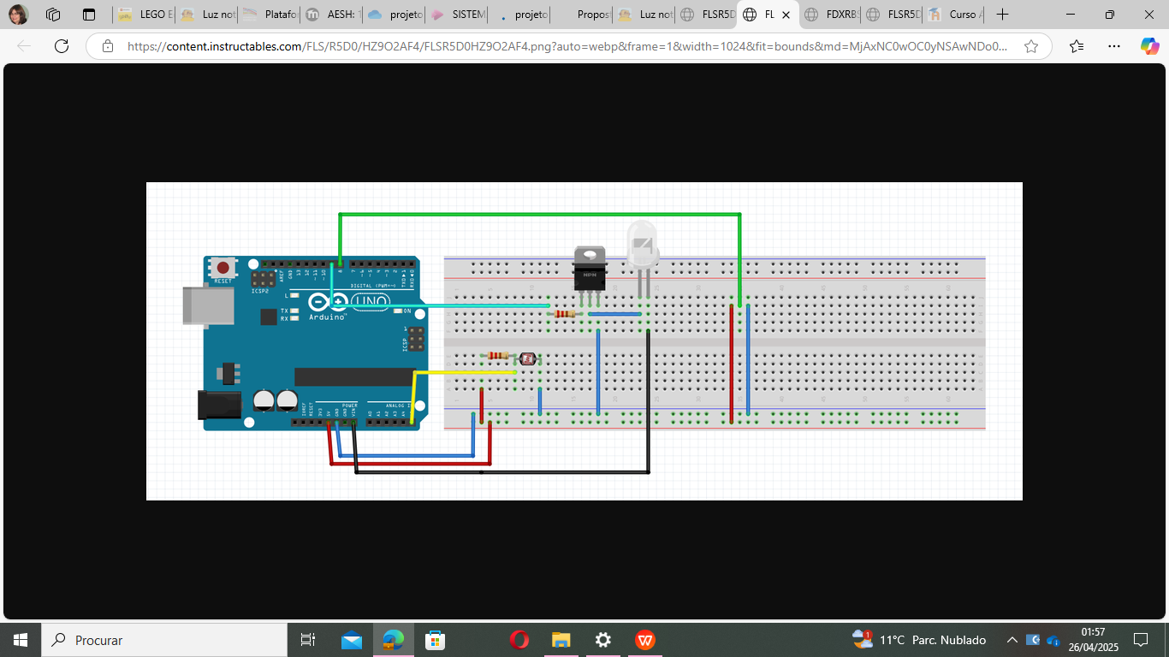

<https://www.tinkercad.com/things/6O4xke3fgOm-projeto-final>